

Excel Assignment - 21

1. Write a VBA code to enter your name in A1 Cell using Input Box and once you enter the name display a message box that says the name has been entered.
2. What are Userforms? Why are they used? How to fill a list box using for loop.

User form is a graphical user interface that helps you have an live interaction with your worksheet which enables you to enter or eliminate data from your excel worksheet through the graphical user interface.

Loops are the fundamental portion of Excel VBA that automates long and repetitive tasks. Loop, as the name suggests, creates a loop, and executes a single task multiple times for all object components or any set number of times described in a loop. There are three types of loops in Excel VBA- the For loop, the Do While loop, and the Do Until loop

A UserForm is basically a pop-up window that you can use to create a custom interface for Excel. This pop-up window allows you to have a more user-friendly interface and to automate Excel in many ways using VBA and macros.

1. What is an array? Write a VBA code to enter students and their marks from the below table.

Arrays in VBA indicate a structure that contains the same type of data in the same place. Arrays can both be one-dimensional and multi-dimensional.

1. Use the following data to create a pie chart using VBA code. Use Font

- ‘Times new Roman’, Size -14, Bold, Title - Piechart’ and you are per to use colours as per your taste.

1. Check the dataset in the link given below and create a pivot table using VBA showing the sales for the year from stationary category.

https://docs.google.com/spreadsheets/d/1IRSEnmgz8Ro276- GslknRNk0zlrB5CZH1YrnT71kqFM/edit?usp=sharing

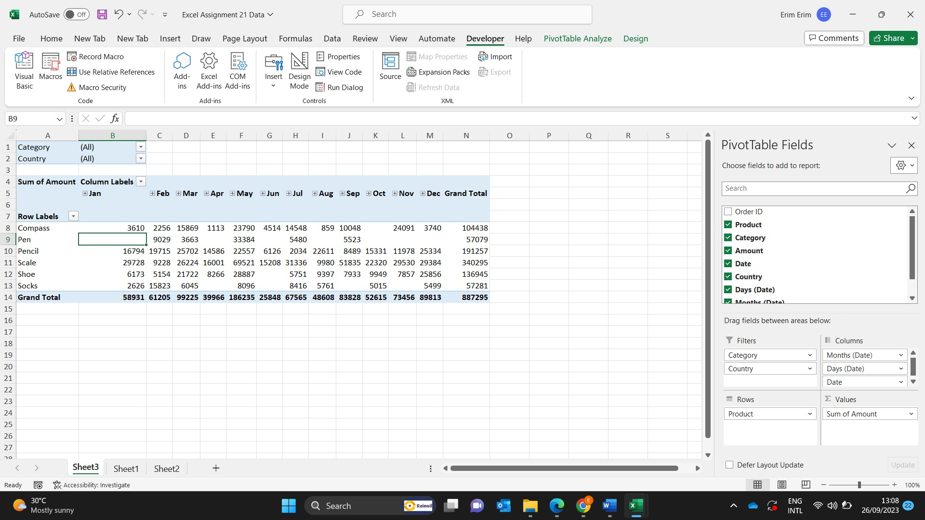

1. Write step by step procedure to protect your workbook using a password.

* Select **File** > **Info**.
* Select the **Protect Workbook**box and choose **Encrypt with Password.**
* Enter a password in the **Password**box, and then select **OK**.
* Confirm the password in the **Re-enter Password**box, and then select **OK**.